Assignment3 Report
Platform (Colab/Kaggle/Local): Colab
Python version: Colab
Operating system: Colab
CPU: Colab
GPU: T4
Remark: For ease of grading, you are encouraged to present data in textual form rather than as images.
- Train a RoBERTa-base model on the same dataset and report the performance of both BERT-base and RoBERTa-base models. (10%)
Results:
  - Discuss the main differences between BERT and RoBERTa, and explain how these differences may affect performance. (5%)
Answer: BERT and RoBERTa share the same Transformer encoder architecture, but differ significantly in training strategies. RoBERTa removes the Next Sentence Prediction (NSP) objective, uses dynamic masking, and is trained on a much larger corpus. In addition to these changes, RoBERTa refines the pretraining process by conducting a more rigorous study on hyperparameters, extending training time, using larger batch sizes, and training on longer input sequences. It also incorporates the CC-News dataset to further enrich the training data. These enhancements allow RoBERTa to outperform BERT in many NLP tasks by better capturing contextual information and generalizing across domains. In this experiment, RoBERTa achieved higher classification accuracy (89.71 %) than BERT (87.44 %), demonstrating that its optimized training strategy indeed leads to improved performance.
Reference: https://medium.com/nlp-tsupei/roberta-%E8%AB%96%E6%96%87%E6%95%B4%E7%90%86-8bcf8a33a5d0
- Train a GPT-2 model on the same dataset and evaluate its performance. (10%)
Results:
  - What are the main difference of BERT and GPT2? Discuss the main differences between BERT and GPT-2, and analyze how these differences influence their performance. (5%)
Answer: BERT and GPT-2 are both Transformer-based models, but they differ fundamentally in architecture and training objectives. BERT is a bidirectional encoder trained using the Masked Language Modeling (MLM) objective, which allows it to understand context from both directions. This makes BERT well-suited for tasks that require deep comprehension, such as text classification, question answering, and named entity recognition. In contrast, GPT-2 is a unidirectional decoder trained with a causal language modeling objective, predicting the next word in a sequence based only on previous tokens. This autoregressive setup enables GPT-2 to excel at text generation tasks, such as story writing, summarization, and dialogue generation.
These architectural differences lead to distinct performance characteristics. BERT typically outperforms GPT-2 on understanding-based tasks. Thus, in this experiment, GPT-2 showed lower accuracy (85 %) than BERT (87.44 %) on classification tasks, which aligns with its design focus on generation rather than comprehension.
Reference: https://vocus.cc/article/68d09ffefd897800015bd32d
- Compare the performance of a multi-output learning model with BERT models trained separately on each sub-task. Does multi-output learning improve performance? Explain why or why not. (5%)
Answer:
In this experiment, we compared a multi-output learning model with BERT models trained separately on each sub-task (regression and classification). The multi-output model jointly learns both objectives using a shared encoder, which helps capture common linguistic features across tasks. Since the two sub-tasks (semantic relatedness and textual entailment) are based on the same sentence pairs, this shared representation is beneficial. However, the regression and classification tasks use different loss functions (MSELoss and CrossEntropyLoss), and their scales may differ significantly. Without proper weighting, one task may dominate the optimization, limiting the overall benefit. As a result, the multi-output model achieved only slightly better accuracy than the single-task models.
- Why does your model fail to correctly predict some data points? Please provide an error analysis and introduce how do you improve your performance. (10%)
Answer: 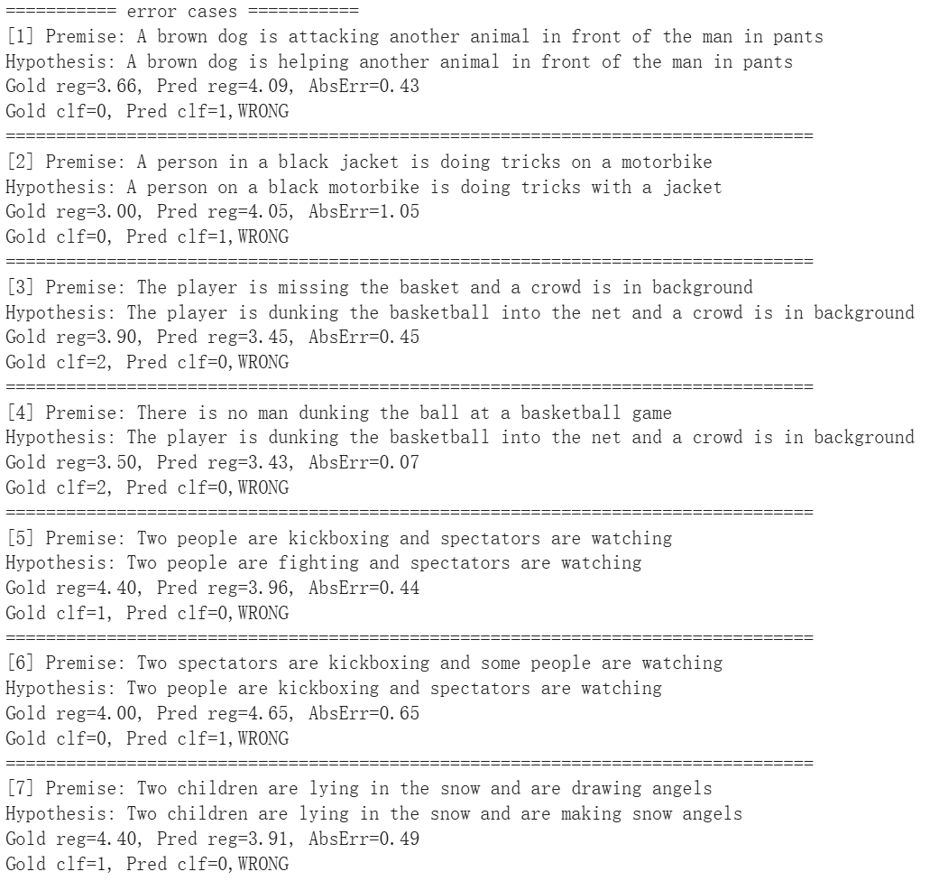
The model's prediction errors mainly stem from challenges in semantic understanding and logical reasoning. It often confused opposite actions like “attacking” and “helping”, and didn’t catch contradictions caused by words like “nobody” or “not”. Sometimes it mixed up who was doing what in the sentence, such as confusing “a family watching a boy” with “a boy hitting a baseball”, or missed the changes like “indoors” versus “outdoors”. It also treated similar words or phrases as having the same meaning, even when they didn’t like “kickboxing” vs. “fighting” or “drawing angels” vs. “making snow angels”. For the regression task, the model gave wrong scores when the sentence pairs had subtle differences, such as the case, where “a girl looking at a woman” was confused with “a girl looks like a woman.” Overall, most of the errors came from the classification task.
- Anything that can strengthen your report. (5%)
Answer: Based on the speculation in Q4 that joint training might be dominated by one loss, I ran a controlled test using uncertainty weighting: I added two learnable log-variance terms log_sigma_reg, log_sigma_clf and optimized loss = torch.exp(-s_r) * reg_loss + s_r + torch.exp(-s_c) * clf_loss + s_c so the model learns per-task weights automatically.
However, the model showed lower accuracy (85.61 %) than BERT (87.44 %), which didn’t improve the original model. Maybe the gap vs. separate sub-task training is not mainly due to one loss dominating. The bottlenecks are not loss scaling.
Reference: https://discuss.pytorch.org/t/balance-between-2-mse-losses/185315/5?utm_source=chatgpt.com
The screenshot of your testing logs and accuracy. (One Figure only) (10%)

